TEACHER NOTES – CO-ORDINATE TRIPLES

Aim: To know how to find the equation of a straight line given two points

Resources: Blank grid
Questions sheet – students cut out the individual cards

Notes

- Students have to work out which cards are the co-ordinate pairs and place those in the top row. The gradient of the line segment between the points fill the second row and the equation of the straight line fill the third row.

Solution

Points | (-7,-1) & (-1,2) | (3,4) & (1,0) | (-3,4) & (3,1)
Gradient |  | 2 | 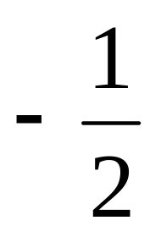
Equation | 2y = x + 5 | y = 2x - 2 | 2y + x -5 = 0

2
2y + x -5 = 0
(-7,-1) & (-1,2)
(3,4) & (1,0)
y = 2x – 2
2y = x + 5
(-3,4) & (3,1)

Points
Gradient

Equation

